

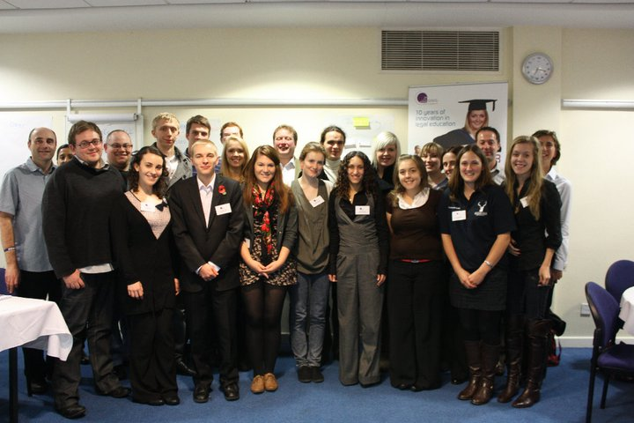
Photograph by Felicia Kyrk

The National Law Students Forum
3-4 November 2010
Manchester Conference Centre

Report by
Laura Carter, Undergraduate Student
York Law School

Session one: The experience of other disciplines

The session was led by Adam Mannis, UKCME & the University of Liverpool.

The focus of the session was placed on the training required to be a Student Representative & student empowerment. It was explained that there is a hierarchy of student involvement within the institution & region:

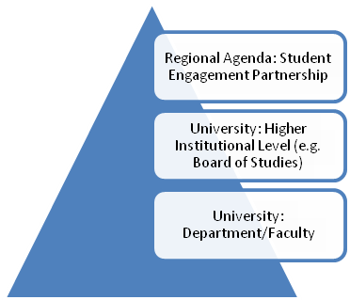

Students (or their representatives) should be encouraged & have the ability to participate in all these levels.

Furthermore, the student, as a Class Representative, can essentially be described as a “Change Agent”. That is, the student has (or should have) the ability to become an educational developer, a discipline promoter, & an appraiser of learning, teaching & assessment. This can only be achieved if the student has, or gains, credibility with staff & academics.

Features of the discipline approach

Staff & students should be actively involved in shaping the educational process. This requires them to gather feedback & constructive criticism, known as “sense-making”. However, it was argued that questionnaires & surveys are not sufficient to fulfil the criteria. It was therefore suggested that more general & informal meetings (for example, the Town Hall Meetings that are held at York Law School) which allow students to present & expand their arguments would be more beneficial & effective. However, that is not to say that questionnaires & surveys have no place at York Law School. I would suggest that the questionnaires circulated during the year in relation to all modules run by the Law School are useful on the basis that they ask open questions & provide room for the students to comment & express their thoughts. Another method which could be used to gather feedback discussed within the session was to ask students to write their comments on post-it notes at various intervals throughout the year. This informal method could lead to students sharing their honest thoughts more frequently & would provide Student Representatives & staff with an up-to-date critique of areas for improvement. Seeking the views of other students provides evidence for comments advanced with staff & generates credibility. Furthermore, it means that the student is able to negotiate & influence the Staff Student consultative process more effectively.

The discipline approach also gives students a “voice”, with them being included as “genuine partners”. This will hopefully lead to the students being trusted & their input being valued by academics. However, there is also a need for Student Representatives to gain added value from subject-specific training, complementing generic training provided by institutions. Training should involve a structured programme of activities & tasks, as well as interactive exercises. The training & development of those students should then be evaluated on a regular basis for the benefit of future students & cohorts.

Student empowerment

Students can feel empowered if they network with other representatives, are able to promote their developments in context, are able to think about the significance of their role & what it involves, if they have a raised awareness of different approaches & techniques (through sense-making, feedback & opinion-gathering), & by gaining an insight into ways to react & appreciate issues.

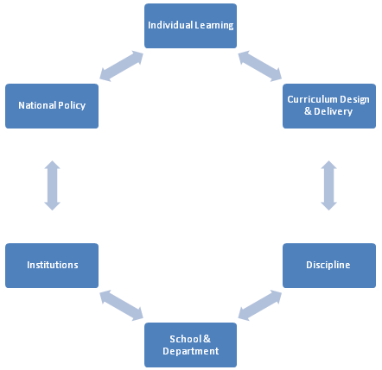
The following shows the areas in which a student can feel empowered:

Together, staff & students should collaborate to develop learning activities & materials for future cohorts. This will expose barriers to learning within the course & areas for improvement.

Key points from the session

- Continue to undertake questionnaires & surveys throughout the year but ensure that these provide students with an opportunity to explain their thoughts fully.

- Continue to hold Town Hall Meetings at the Law School communicating the results of such surveys & presenting students with the opportunity to clarify their comments.

- Perhaps provide more regular & informal opportunities for feedback from students, possibly including the chance to make notes on post-it notes. Arrange this with the help of Student Representatives.

Session two: Credibility of representatives

The session was led by Ant Bagshaw, NUS.

We began by discussing the various forms of informal engagement that students can have with staff within their department, for example:

- Student Representative or students generally having a coffee with staff;
- Emails;
- Inviting staff to social events;
- Discussing the interests outside of law that staff have;
- Networking events run through Law Societies;
- Learning about academic alumni; &
- Having shared common rooms for staff & students.

Being a comparatively smaller law school to that of some of the participants, it is perhaps unsurprising & to its credit that most of these forms already take place at York Law School. Staff have in the past & presently, been invited to social events such as go karting or meals with Student Law Firms, discussed issues over coffee, & generally discussed their outside interests with students in a variety of contexts.

Example scenarios

We were then split into groups & asked to discuss a number of potential schemes that could be run by law schools.

Scenario one: Student academic partners

The scheme would involve academics within the law school becoming involved in activities more usually associated or run through law societies. This splits into three distinct categories: careers, voluntary work/pro bono, & skills.

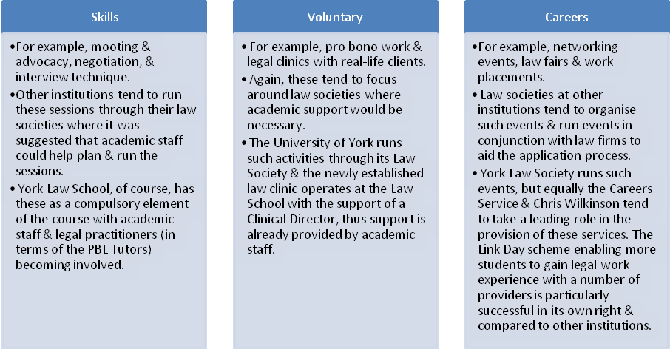

Scenario two: Mentoring schemes in the department

The scheme would see first year students paired to second or third year students in a peer mentoring scheme. Any academic or other issues could be shared with & dispelled by the mentor. In doing so, the mentor would further develop their communication skills. However, the mentor & mentees would need to be paired well for the scheme to be successful which was evidenced through the experiences shared by participants from other institutions. Here it was suggested that students should be encouraged to complete questionnaires so that matches in terms of location, age, & interests, for example, could be made. Moreover, issues relating to the number of mentees to be designated per mentor would need to be decided upon, with some institutions taking the view that 3-5 mentees per mentor was sufficient, & other mentors being left to supervise 40 mentees in consequence of the lack of engagement on behalf of the mentors. In response, the suggestion was that there is sometimes a need to incentivise such schemes over & above the benefits of being able to list the scheme on a CV, for example, gaining extra academic credit for participating or being presented with awards under the scheme. The concept of mixers for mature students (across disciplines) was supported, as was the idea of having informal ice-breakers to introduce mentees to mentors. It was unclear whether this should be run through the law school or law society & whether the relationship should be formal or informal, though this could be decided by the individual pairings. The overall experience of such schemes was that the smaller the law school or cohort, the more successful the scheme would be. [See also notes for Session Three & Key Recommendations.]

Scenario three: Student engagement conference

Conferences between Student Representatives, staff & practitioners should be reported & made available online to the whole cohort. This would make such meetings transparent & would give other students the chance to give feedback on the issues raised, increasing the credibility of the conferences & the ability of staff involved to make noticeable & effective changes. Involving practitioners in such conferences would lead to greater links being made between law firms, students, & law schools overall, with the opportunity for them becoming involved in law fairs.

Scenario four: Student forum

In addition to the “sense-making” methods outlined in the Session One notes, it was suggested that the opinions of students could be gathered through the law society, online blogs & facebook, for example. This would increase accessibility to resources & present students with more opportunities to become more actively involved in the future & improvement of the law school.

Session three: Discussion sessions: Priorities for law students

The session was led by Adam Mannis, UKCME & University of Liverpool.

The emphasis of the session was to find the areas that law students believe need to be prioritised in legal education.

Moreover, we were informed of the statistical analyses that are available to students, most commonly as a result of the National Student Survey, in order to evaluate the performance of a law school. With York Law School in only its third year, such analysis is not available. However, it seemed that the University of Northumbria is closest to York Law School in terms of teaching method & substance, & the Hull York Medical School from within the University of York which utilises Problem Based Learning is the most closely matched department within the university. At the end of this report, you will find a copy of the National Student Survey results for those two institutions & courses. Whilst most areas score an agreement level of over 70%, the assessment & feedback sections receive scores as low as 42%, thus I would suggest that York Law School ensures that: it clearly states the criteria that is going to be used for making assessments in advance; marking is fair; feedback on assessment is prompt; & it provides detailed comments on work to ensure that the student is clear on the areas that they need to improve on. I would argue that the former two statements are met by York Law School, however, doubts have been raised in the past by students in relation to the level of detail & usefulness of the feedback provided, which may be a result of its growing size & the need to manage the workload of staff.

After brainstorming in groups & sharing ideas, it was found that the top three priorities for the participants were:

- Employability & Skills;
- Teaching & quality; &
- Mentoring & support.

I will not discuss employability & skills here as I think this has been addressed in my section on Session Two, & York Law School offers these activities already.

Teaching quality

Students raised the issue of fees –v- value, especially in light of the recent proposals to raise tuition fees. Students are likely to question not only why fees have been raised, but where they are benefitting from the raises, in terms of contact time or quality or both. A greater focus will be placed on the consultation process to ensure that the needs of the students are being met, especially as they will be paying more.

It was suggested that there will be a need to appreciate & accommodate the different learning styles of individual students & a need to produce learning aids for a diverse cohort. This could lead to lectures being recorded, skills sessions being provided, podcasts being available & online resources becoming more accessible. To produce such resources would be time consuming, but the overall suggestion was that students could become involved in the process & take a role in recording, for example.

To assess the quality of teaching, further questionnaires could be undertaken, with students or their representatives taking a role in devising the surveys.

Mentoring & support

For this session I sat with the mentoring & support group as York Law School does not yet have a mentoring scheme aside from the formal staff support in the form of the Personal Advisor system.

The group produced the following model that could be used to form a mentoring system, or clarify a pre-existing one:

STUDENT
(New or Old)
☹
HANDBOOK
Compiled with students & staff involvement.
Includes FAQ’s such as searching for cases, taxi numbers etc.

STAFF

CURRENT STUDENT/ MENTOR

HAPPY STUDENTS
☺
COMMUNICATE WITH STAFF.
Consultation & review.

Check with staff.

Advise best route.

ISSUE!
Peer Mentoring System.
Formal & informal.

Informal email & response.
Meeting with Personal Advisor or referred to Module Leader/most relevant member of staff.

ISSUE!
Structured Personal Advisor system from Day One. Regular meetings & explanation of system.

Session four: Communications and negotiation skills workshop

The session was led by Rebecca Huxley-Binns, Nottingham Trent University & UK Law Teacher of the Year 2010.

The session was an introduction to the communication & negotiation skills required in professional practice with a focus on legal practice. These skills are particularly relevant in the context of networking events & practising as a solicitor or barrister. Overall, the session provided a strong introduction for those that had not been involved in negotiation exercises before.

We began by discussing the need to listen to client instructions rather than interpreting them to meet our own interests or ideas. Furthermore, we looked at the various negotiating strategies & styles available within a negotiating context before moving on to discussing the skills necessary to negotiate successfully, such as listening, following and interpreting instructions, thinking & questioning, planning, acting on that plan, reappraising, & foreseeing/predicting the outcome of negotiations. We briefly moved on to discuss BATNAs.
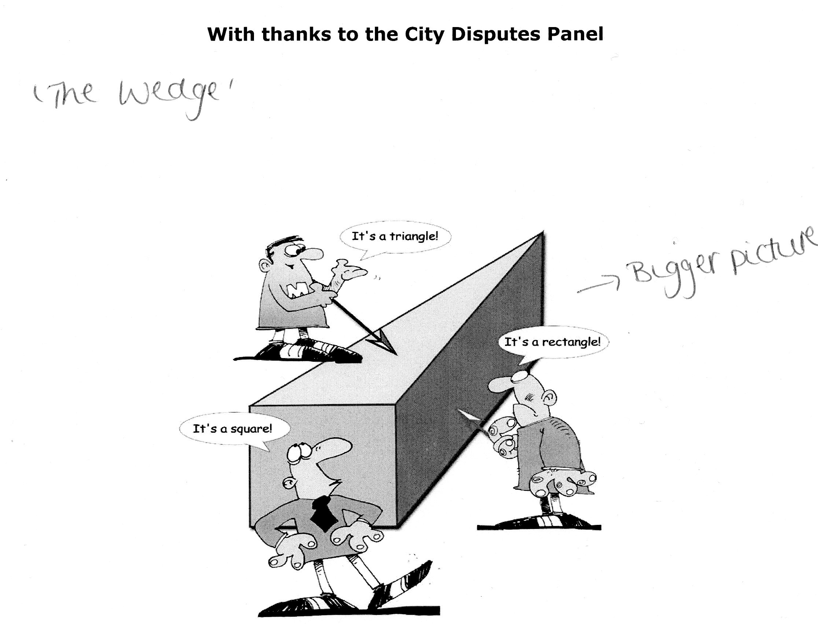
The image shown here of “The Wedge” was used as a visual aid to support the idea that the parties within negotiations will have some common or shared facts & alternately some undisclosed or personal facts that the other party does not have access to.

We undertook a fictional telephone negotiation in pairs to end the session which was similar to Skills sessions that we have at York Law School, albeit this was at a much faster pace & with little time for planning.

Session five: simulated staff and student meeting

The session was led by Michael Bromby, Glasgow Caledonian University.

The focus of this session was on the Staff Student consultative process with a simulated role-play based on a number of scenarios. The most relevant of those scenarios are detailed below.

Scenario one: Feedback & deadlines

The scenario revolved around essays for assessment modules being due at the same time & the chance that feedback would not be provided before the exams. The students argued that the early deadline may mean that the whole syllabus would not have been covered with the result of an overall low standard of work. The suggestion here was to choose a subject that had been covered earlier in the module, or to divide the assessment so that one part was completed midway through the course & the second part at the end of the module, meaning that the workload would be spread & the understanding of the students would be at the required level. The “staff” within the role play argued that it was the students’ responsibility to manage their time efficiently, but also stressed that the ability of staff to deliver feedback before the exams would place an extra pressure on time & financial constraints, especially for larger law schools with a larger cohort. Staff suggested that the students could submit their work earlier for a greater chance of feedback before the exams, or that an earlier submission date could be set to guarantee feedback, though it would be for the student to choose whether to submit early or submit at the later date. Staff emphasised that independent research would be important & that second & third year students should have an idea of their capabilities & the time it would take them to complete such assignments. Whilst this discussion was successful, it was decided that its outcomes would take time to implement & would not be immediate.

Scenario two: Key text issues

The scenario centred on the availability of key texts from the library. The key text(s) in question were not supplied well by the library & were very expensive for students to purchase. [In one of the institutions present at the Forum, it was common for students to take copies for as long as possible & not return them (or photocopy them), & even for books to be hidden in the library in other sections so that they could not be taken out by other students.] The students proposed that there should be one key text to every 10 students as this would be an investment for the future, with some in key texts & some available for a longer loan. It was also suggested that the campus-based book retailer could offer students a discount to relieve some of this pressure but this would obviously require the support of staff. Staff argued that research is significant as a law student, & thus encouraged students to locate e-sources & use other libraries. Furthermore, it was argued that the cost to the university & library would be extensive & this is not always possible within a discipline that is constantly changing. The size of the cohort would impact upon the number of books available.

Scenario three: Standardisation & accessibility of academic notes from lecturers

The scenario focused on a lecturer not making available their lecture notes, & in fact refusing to do so. Additionally, the lecturer would not use visual aids which was a continuing issue. Students asked for transcripts or recordings to be made available & offered to take a role in making the necessary materials for future year groups. Staff argued that there would be a considerable cost to record such lectures & questioned what the level of attendance would be if lecture notes were put online. Staff told the students to communicate further with the lecturer. This leads to greater questions of standardisation: for example, should there be a department policy on the information that should be made available to students on the VLE? Should all lecturers be told to upload a copy of their lecture notes? Should they have to do this before the lecture? This consistency could lead to, conversely to the previous assertion, a higher level of participation & understanding, rather than a drop in attendance.

Scenario four: Late lectures

The scenario looked at students leaving campus late on an evening, especially when it was dark. This raised issues of a lack of nearby parking & student safety. Students argued that parking permit allocation could take place online & be based on a merits system. On the other hand, separate permits could be given to day & evening students. In terms of security issues, it was suggested that better lighting & CCTV could be provided. Whilst staff were willing to discuss the issues, it was decided that a plan would need to be devised & presented to the university board rather than the law school staff.

Key recommendations

Peer Mentoring Scheme

The majority of institutions being represented at the Forum had established peer mentoring schemes. The best aspects from shared experience were:

- Given that York Law School is a relatively small school in comparison to others, I would recommend that a peer mentoring scheme runs through the Law School rather than York Law Society. However, the Law Society could become involved in the case of there not being enough volunteers to be mentors.

- Mentors would be given a minimum of 3 mentees, but I would recommend that the maximum number of mentees should not exceed one Student Law Firm per mentor. To some extent, this would depend on the number of mentors available.

- Design (with the help of students) “suitability” questionnaires to match mentors & mentees by personality. This should result in better relationships being made between the pairings & the pairings not breaking down. Pairs could be matched based on age, nationality/location & interests.

- Hold ice-breakers for mentors & mentees to encourage them to trust each other & support each other during the year. This should lead to the relationships being more informal & the mentees should then feel more able to contact or discuss issues with their mentor.

- The incentives to the mentors should be clear in terms of being able to include their role on their CV & job applications. I would imagine that this would be enough for older students to take a role in the system, especially given the friendly nature of the Law School at present. To some degree, an informal system is already taking place because of the size of the Law School, but a formalised approach would ensure that all first years would have a contact aside from the member of staff that is their Personal Advisor.

- Use a model along the lines of that shown in Section Three of this report. Highlight to the new students the routes available to them. The model also shows the need for there to be communication between staff & students to ensure that the system works as effectively as possible. Furthermore, the suggestion of a handbook written by staff & students together should provide the new students with a first source of advice, which would be particularly helpful for smaller issues such as locating journal articles.

Careers

Maintain links with the careers service at the university. Other institutions hold law fairs but the links that York Law School has with law firms & chambers are stronger than that of other universities it would seem. The advice they give in relation to vacation scheme & training contract applications is especially helpful & from discussions with the other participants “Link Days” have not been introduced elsewhere, but there would be a demand for this if it was offered.

Skills

The Skills Development Sessions as part of the law degree at York Law School are seen at very few other institutions, which have to offer such sessions through their law societies. Other institutions were impressed with this aspect of the York course.

Future of the Forum

This Forum was a pilot event, but it is likely to become an annual event. It was further suggested that regional events could be held to encourage more law schools & students to become involved. If the Forum continues to run, I would recommend that a representative of York Law School attends to share experience & gain an insight into the operation of other law schools. It is likely that the substance of the Forum will change over time which will allow participants to gain something new every year. Whilst it would be beneficial for the same representative to attend each year, this is clearly not possible due to students graduating & others being nominated as Student Representative. However, a different delegate each year could bring new ideas to the table, so this would still be useful.

